Lab 2 (2%)

Uncorrelated subqueries

**topics**

uncorrelated queries

**Group work acknowledgment**

We, Mansoor Ahmad Zafar, declare that the attached assignment is our own work in accordance with the Seneca Academic Policy. No part of this assignment has been copied manually or electronically from any other source (including web sites) **or distributed to other students.**

Specify below what each member has done towards the completion of this work:

Name Task(s)

1- Mansoor Ahmad Zafar Everything

2-

3-

**Before you start**

You are to create a new database named “AviaCo” and run the sql script you are given to create the tables in the database.

**Instructions**

For each of the following questions write the sql query (in text) and show the result set underneath each SQL query.

1. What is the maximum charter fuel consumption per hour. Fuel consumption per hour is calculated as follows: fuelPerHr= CHAR_FUEL_GALLONS/ CHAR_HOURS_FLOWN.

Query:

select max(CHAR_FUEL_GALLONS/CHAR_HOURS_FLOWN) as 'max fuel consumption per hour'

from charter

Output:



1. Show the charters that have the highest fuel consumption per hour.

Fuel consumption per hour is calculated as follows:

fuelPerHr= CHAR_FUEL_GALLONS/ CHAR_HOURS_FLOWN.

-- use query 1 as subquery in a where clause.

Query:

select CHAR_TRIP, max(CHAR_FUEL_GALLONS/CHAR_HOURS_FLOWN) as 'fuelPerHr'

from charter

group by CHAR_TRIP

having max(CHAR_FUEL_GALLONS/CHAR_HOURS_FLOWN) = (select max(c.CHAR_FUEL_GALLONS/c.CHAR_HOURS_FLOWN) from charter c)

Output:

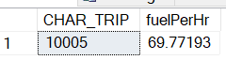

1. Z-score transformation is a numerical transformation of a distribution/series of values that puts the values in a scale of [-3 3].

Show the charter trip and the fuel consumption per hour and the standardized fuel consumption per hour or Z-score. Fuel consumption per hour is calculated as follows:

fuelPerHr= CHAR_FUEL_GALLONS/ CHAR_HOURS_FLOWN.

the standardized fuel consumption per hour or z-score is calculated as follows.

Z-score = (fuelPerHr - avg(fuelPerHr))/stdev(fuelPerHr).

Query:

select top 5 CHAR_TRIP, (CHAR_FUEL_GALLONS/CHAR_HOURS_FLOWN) as fuelPerHr,

((CHAR_FUEL_GALLONS / CHAR_HOURS_FLOWN) - (select avg(CHAR_FUEL_GALLONS / CHAR_HOURS_FLOWN) from charter)) /

(select stdev(CHAR_FUEL_GALLONS / CHAR_HOURS_FLOWN) from charter) as 'FuelPerHr_zscore'

from charter

Output: first 5 rows out of 18

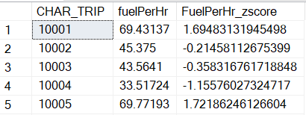

1. Find the charters that exhibit outliers in fuel consumption per hour. Check for standardized fuel consumption per hour larger than 1.5 or less than -1.5.

-- use query3 in a “from” clause.

Query:

select c.CHAR_TRIP, c.fuelPerHr, c.FuelPerHr_zscore

from

(

select CHAR_TRIP, (CHAR_FUEL_GALLONS/CHAR_HOURS_FLOWN) as fuelPerHr,

((CHAR_FUEL_GALLONS / CHAR_HOURS_FLOWN) - (select avg(CHAR_FUEL_GALLONS / CHAR_HOURS_FLOWN) from charter)) /

(select stdev(CHAR_FUEL_GALLONS / CHAR_HOURS_FLOWN) from charter) as 'FuelPerHr_zscore'

from charter

) as c

where c.FuelPerHr_zscore > 1.5 OR c.FuelPerHr_zscore < -1.5

Output:

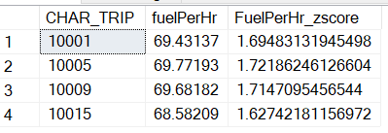

1. Calculate the average hourly fuel consumption per each charter destination and show only the charter destinations that have average hourly fuel consumption greater than 40.

Show also the number of charters per destination.

The hourly fuel consumption per hour is calculated as CHAR_FUEL_Gallons/CHAR_HOURS_FLOWN

Query:

select distinct c.CHAR_DESTINATION, (select count(charter.CHAR_TRIP) from charter where charter.CHAR_DESTINATION = c.CHAR_DESTINATION) as 'number of charters',

(select avg(charter.CHAR_FUEL_GALLONS/charter.CHAR_HOURS_FLOWN) from charter where charter.CHAR_DESTINATION = c.CHAR_DESTINATION) as 'avg fuel consumption'

from charter as c

where (select avg(charter.CHAR_FUEL_GALLONS/charter.CHAR_HOURS_FLOWN) from charter where charter.CHAR_DESTINATION = c.CHAR_DESTINATION) > 40

Output:

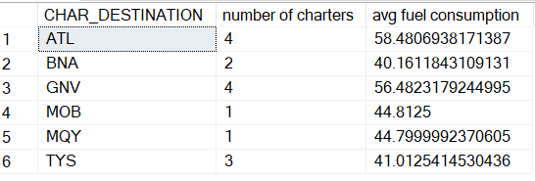

**SUBMISSION**

Submit your lab2_GroupX.doc file on BB. Replace X with your group number.

If a student does not contribute to the work, do not list his/her name(s) under the group section in the lab file and will get 0.

**Grading rubrics**

Each question is worth 5pts. Total is 25 pts. If the output is included without the query, the answer is worth 0.